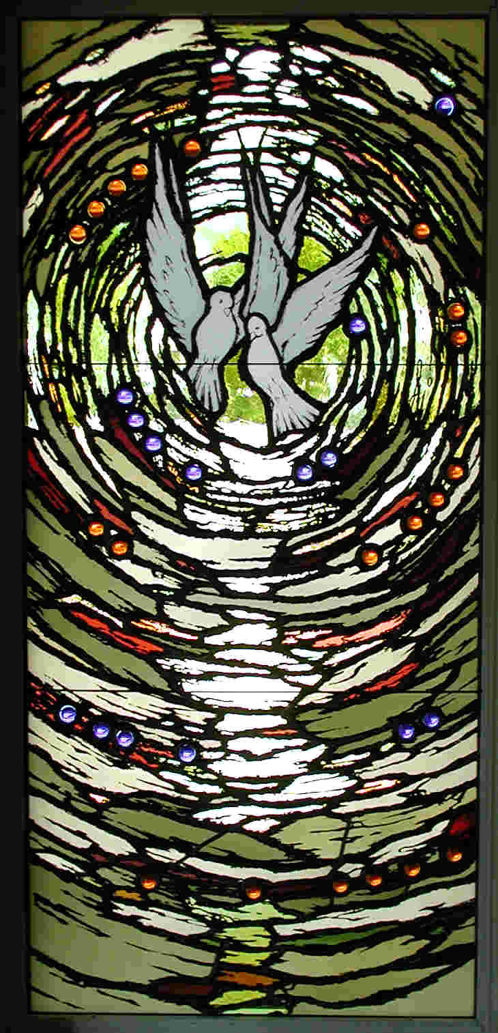

**Weddings at Emmanuel**

# Emmanuel Episcopal Church

1608 Russell Road

Alexandria, VA 22301

703-683-0798

www.emmanuelonhigh.org

[office](mailto:office)@emmanuelonhigh.org

***A Note from the Rector***

Congratulations! You’ve decided to get married! How wonderful! We at Emmanuel wish you a long and happy married life. We will do all in our power to help you get off to a good start and sustain you in your life together. We are also glad that you have chosen to seek God’s blessing and to celebrate your wedding in the Episcopal Church.

Preparing for your marriage may be a hectic time, but it should also be a joyful and prayerful time as well. In the marriage liturgy we pray:

*“Almighty and ever living God:*

*look tenderly upon N. and N.,*

*who stand before you in the company of your Church.*

*Let their life together bring them great joy.*

*Grant them so to love selflessly and live humbly,*

*that they may be to one another and the world*

*a witness and a sign of your never-failing love and care;*

*through Jesus Christ your Son our Lord,*

*who lives and reigns with you and the Holy spirit,*

*One God, to the ages of ages. Amen.”*

Love, selflessness, joy, and humility are the cardinal virtues of marriage. Hence marriage is intended by God to be a life-long covenant that “*is not to be entered into lightly or thoughtlessly, but responsibly and with reverence.”*

This booklet is provided to help guide you on the way. It contains and explains the customary guidelines for weddings at Emmanuel, the first of which is a meeting with me, the Rector, The Rev. Charles C. McCoart, Jr. (Chuck).

Please call the church office if you would like to make an appointment or have any questions. We are here to help.



Peace,

**Compliance with the regulations of the Commonwealth of Virginia**

* Virginia requires all persons who perform marriages to be licensed by the State.
* Virginia also requires a marriage license for the couple. The license can be obtained from any city or county in the Commonwealth.

**Compliance with the requirements of the Episcopal Church**

* Sign the Declaration of Intent which will be provided to you by the Rector.
* The canons of the church require at least 30 days notice before a wedding date is set and in cases where one of the partners has been married before, the written permission of the Bishop is required before a wedding date may be set.
* Pre-marital instruction with one of the Clergy on a regular basis for several months before the ceremony (minimum of 3 sessions) is required. These sessions deal with the spiritual, practical, and pastoral aspects of marriage as well as the details of the ceremony.
* At least one of the parties must be a baptized Christian.
* The couple may choose, with the Rector’s permission, to use any of the marriage liturgies authorized by General Convention of the Episcopal Church, be they in the Book of Common Prayer or in the Supplemental Liturgies provided by the Standing Commission on Liturgy and Music.

**Planning**

***Scheduling:*** Contact the Rector to select a date that is compatible with the parish calendar. Six months notice is advisable.

* Generally, weddings will not be scheduled during the season of Lent, on a Friday night when another Saturday wedding has been scheduled, or within one week of a major holiday such as Christmas or Easter.
* Weddings may be scheduled in the church or chapel at any time until 7:00 p.m. Rehearsals are generally held at 5:00 or 6:00 p.m. on the previous day.
* The church seats about 250 people and the chapel about 40 people.

***The Service:*** The marriage ceremony is a worship service and as such is under the direction of the Clergy with the assistance of the Altar Guild. The Eucharist may be a part of any wedding at Emmanuel. All are welcome to receive communion at Emmanuel.

***The Wedding Rehearsal:*** The date and hour of the rehearsal should be set when arranging for the date and hour of the wedding. The rehearsal shall always take place prior to the rehearsal dinner and will be conducted by the officiating priest. The following people (where applicable) should be present:

* The couple to be married.
* The couple’s parents.
* All attendants and members of the wedding party.
* Ushers.
* Musicians (if requested; additional fee will apply)

***Reception at the Church:*** Our parish hall is available for a reception at the church. It can accommodate up to 150 people. We do not have catering facilities. Alcohol consumption is permitted according to the following restrictions:

* Champagne, beer or wine only.
* No hard liquor.
* A non-alcoholic beverage alternative must be provided and served in an equally attractive manner.
* Punches and drinks must be labeled “alcoholic” or “non-alcoholic” and care must be taken to assure that minors are not served alcohol in any form.
* You may be required to arrange for a temporary ABC banquet license. Please contact the parish administrator for further information.

**FLOWERS**

You may use your own florist, or you may call the florist our Altar Guild uses: Conklyn’s Florist (703-299-9000). In the case of a Saturday wedding, the altar flowers could be kept on the altar for the Sunday services and designated as given by the couple in thanksgiving for their wedding.

**USHERS**

Ushers should be available to seat guests. One usher for each 50 guests, no less than two, is suggested. Ushers should station themselves at the church entrance at least 45 minutes before the ceremony.

**MUSIC**

Any music used at a wedding should be appropriate for a worship service, dignified and religious in nature. The parish organist customarily plays for the wedding, but if unavailable a substitute will be found. The parish organist also arranges for a cantor to lead the singing of hymns.

If a couple wishes to use an outside musician, or a guest organist, they must contact the resident music director via email (address found on page 6) to discuss use of instruments. Additionally, it is customary for wedding couples to pay a bench fee of $50 to the Emmanuel Music Ministry for use and care of the organ, piano, microphones, and other music equipment.

**PHOTOGRAPHY**

Photographs may be taken before and for 30 minutes after the service in the church. During the service photographs without flash may be taken from the back of the church. It is requested that the photographer not take pictures in the center aisle during the procession or the service. Weddings may be videotaped. Please have your photographer consult the Clergy for more specific directions.

**RICE AND/OR CONFETTI**

Rice, confetti or bird seed should not be thrown inside or outside the building. This custom should be reserved for the final “farewells” at the reception. If the reception is being held at the church, we ask that only bubbles be used.

**FEES FOR WEDDINGS AT EMMANUEL**

The following fees apply to all weddings (please make checks payable as indicated):

* Organist: ***Ryan Fitch***

Wedding (2-hour maximum) $300

* Vocal Soloist: *(Name will be supplied.)* $100
* Rehearsals, if requested: ***Ryan Fitch*** $100

(Minimum of 1 hour at $100 per hour)

* Bench Fee: ***Emmanuel Episcopal Church*** $ 50

(If applicable.)

* Parish Hall Rental: ***Emmanuel Episcopal Church*** $250
* An honorarium for the Clergy or a contribution to the Rector’s Discretionary Fund is both customary and welcome. The suggested amount is $300. The check should be made payable to ***Emmanuel Episcopal Church*** with ***RDF*** in the memo line. Donations made to the Rector’s Discretionary Fund are used to help others in need.

Individual checks to the appropriate party are to be submitted to the Clergy at the final counseling session or to the Parish Administrator prior to the wedding.

**PLEASE CONTACT THE FOLLOWING PERSONS TO MAKE YOUR WEDDING ARRANGEMENTS:**

Rector

***The Rev. Charles C. McCoart, Jr. (Chuck)***

To set the date and time,

and make Clergy and counseling arrangements.

(703) 683-0798 or charlescmccoartjr@gmail.com

Music Director/Organist

***Ryan Fitch***

Regarding all musical arrangements.

musicdirector@emmanuelonhigh.org

Parish Administrator

Regarding payments and parish all rental.

***Janie Piemonte***

administrator@emmanuelonhigh.org

*Photo by Beth Boland*